## Customiseable feeds to include the following.

**Nicholas Buckland**

Director

The Lumin Group

**P:** 0433 596 353

**E:** [nicholas.buckland@thelumingroup.com.au](mailto:nicholas.buckland@thelumingroup.com.au)

**W:** [www.thelumingroup.com.au](http://www.thelumingroup.com.au)

## Additions

Please also include an option to input

* member’s linked in photo
* Company logo
* Supporting logo’s
* Privacy statement
  + *IMPORTANT: The contents of this email and any attachments are confidential. They are intended for the named recipient(s) only. If you have received this email by mistake, please notify the sender immediately and do not disclose the contents to anyone or make copies thereof.*
* *LinkedIn page is* [*https://www.linkedin.com/company/89982985/admin/feed/posts/*](https://www.linkedin.com/company/89982985/admin/feed/posts/)

Company logo is (see both options)

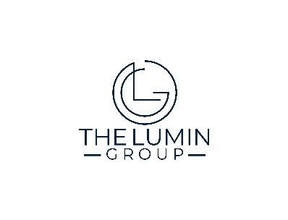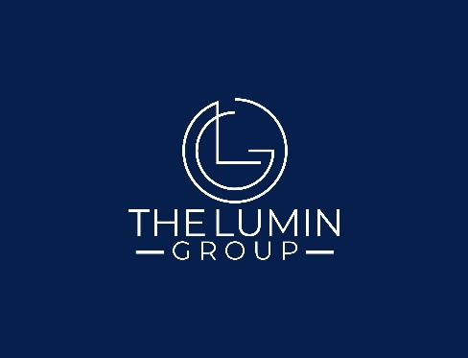

Supporting logos/memberships

 and 

Some of our company slides so you can understand our design/theme.

